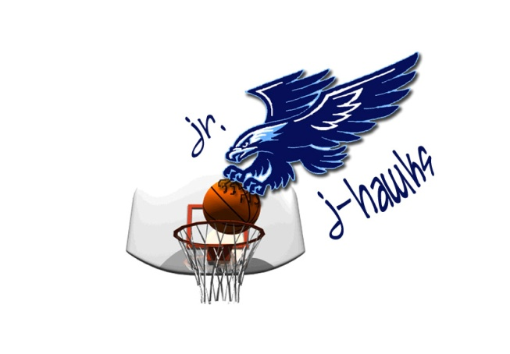
7th Annual Cedar Rapids J-Hawk Girls Alumni Basketball Shootout
- February 18th/February 19th at Jefferson High School (4th-5th play Saturday only. 6th-8th play Sunday only)
- 150 dollars entry (Feb. 8th deadline), 3 game guarantee tournament format will be pool play into single elimination bracket but may vary depending on number of teams entered
- 4th-8th grade girls, 12 team max. for each age group. NO all-star teams
- Trophies/medals for first and second place of gold bracket only (10 max.)
- IHSGAU rules with exception of 16 minute halves for 3rd-5th and 18 minute halves for 6th-8th
- Included waiver must be turned in prior to your first game. Full rules will come later.
- 2 certified officials for every game, scorekeepers provided
- NO individual will profit, this is a fundraiser for our program
- 5 dollar per person admission, Children 9 and under are free
Team Name______________________________ Grade Level___________
Coach______________________________ E-Mail_____________________
Cell # _______________
Assistant Coach______________________ E-Mail ____________________
Cell # _______________
Experience LOW MID HIGH
This year we are teaming up with the Jr. Warriors who will host a 3 game guarantee for 150 dollars the same weekend at Cedar Rapids Washington. Their tournament will have 3rd-5th play Sunday and 6th-8th play Saturday. If you sign up for both the Jr. J-Hawk tournament and Jr. Warriors tournament you will get a 15 dollar discount on each tournament. That is a 6 game guarantee for just 270 dollars!

Player | Jersey #
1.
2.
3.
4.
5.
6.
7.
8.
9.
10.
11.

Please make checks payable to Jr. J-Hawk Basketball
Entries can be mailed to:
6809 Boulder Dr. NW Cedar Rapids, IA 52405
For more info or questions please contact Jake Koolbeck. Email: jake.koolbeck@gmail.com Cell: 319-432-1850
You can contact the Jr. Warriors and Renell Strait at tihoops@live.com to get more info and a registration form for the Jr. Warrior tournament.
J-Hawk Shootout Waiver

Please have all players sign in the left column, with their parent/legal guardian signing in the adjacent right column.

The signing of this sheet acknowledges that parents, players, coaches, and spectators that are participating or attending the Cedar Rapids J-Hawk Girls Alumni Basketball Shootout acknowledge and accept that they are fully responsible for their own property and possible injuries that may occur while at this tournament. Cedar Rapids Jefferson High School, the Jr. J-Hawks, school employees, and tournament volunteers are not responsible for any lost/stolen property or for any injuries to any participate or spectator while they are involved in the Cedar Rapids J-Hawk Girls Alumni Basketball Shootout.
Player | Parent/Guardian
1.
2.
3.
4.
5.
6.
7.
8.
9.
10.
11.
12.

